|  |  |
| --- | --- |
| Final Project Report | Megha Sharma Divya Singh Greg Hutchins  Anupam Swain |

Table of Contents

Overview 3

Defining 3

**Error! Hyperlink reference not valid.Error! Hyperlink reference not valid.Error! Hyperlink reference not valid.Error! Hyperlink reference not valid.Error! Hyperlink reference not valid.Error! Hyperlink reference not valid.Error! Hyperlink reference not valid.**Planning 7

Executing 12

**Error! Hyperlink reference not valid.Error! Hyperlink reference not valid.Error! Hyperlink reference not valid.Error! Hyperlink reference not valid.**Closing 14

References 16

Appendix A: SCHEDULE TABLE 17

Appendix B: GANTT CHART 18

Appendix C: GANTT CHART WITH SCHEDULE TABLE LEVELING WITHIN SLACK 19

Appendix D: GANTT CHART WITH SCHEDULE TABLE LEVELING OUTSIDE SLACK 20

Appendix E: GANTT CHART WITH SCHEDULE TABLE PRESENTING THE NEW SCHEDULE 21

Appendix F: QUARTERLY CASH FLOW 22

Appendix G: COST TABLE 23

Appendix H: GANTT TRACKING TABLE FOR QUARTER 1 24

Appendix I: GANTT TRACKING TABLE FOR QUARTER 2 25

Appendix J: GANTT TRACKING TABLE FOR QUARTER 3 26

Appendix K: GANTT TRACKING TABLE FOR QUARTER 4 27

Appendix L: EARNED VALUE REPORT FOR QUARTER 4 28

Table of Figures and Tables

The Triple Constraint 5

Project Priority Matrix 6

Conveyor Belt WBS 6

WBS of Conveyor Belt in MS Project 7

Advantages and Disadvantages to the Network Diagram and Gantt Chart 8

Critical Path 8

Risk Severity Matrix 9

Risk Assessment Form 10

Risk Response Matrix 10

Contingency Reserve 11

# Overview

On August 22, 2018 the project management team was tasked with producing a new system for future installations of a conveyor belt which moves and positions items within < 1 millimeter. In order to accomplish this task, the team met on multiple occasions to address the five major stages of the project lifecycle outlined below.

1. Defining
2. Planning
3. Executing
4. Closing
5. Monitoring and Controlling (on-going throughout each stage of the lifecycle)

Each stage produced several artifacts which assisted in multiple areas in managing the project and informing senior management on progress. Following is an overview of each stage within the lifecycle and how the team leveraged the artifacts to work towards a successful completion.

# Defining

# In the Defining stage of the project lifecycle the project team reviewed all of the objectives, deliverables and scope of the conveyor belt project. Components of this stage which assisted the team in current and future stages included analyzing the requirements, developing the project scope statement, establishing the project’s priorities, creating the work breakdown structure (WBS) and coding the WBS.

## Analyzing the Requirements

Each one of the below requirement’s were discussed among the project team and assisted in developing the project scope statement:

* Business requirement(s) - the higher-level needs of the organization (includes the reasons why the project is being undertaken)
* Stakeholder requirement(s) - the needs of stakeholder(s) or stakeholder groups
* Solution requirement(s) - description of the features, functions, and characteristics of the project. Includes:
  + Functional requirements which describe the behavior(s) of the product
  + Nonfunctional requirements which describe the environmental conditions or qualities required for the product to be effective
* Transition and readiness requirements - the temporary capabilities needed to transition from the current to a future state
* Project requirements - the actions, processes, or other conditions the project needs to meet
* Quality requirements - the condition(s) or criteria needed to validate the successful completion of project deliverables

## Defining the Project Scope

After the team assessed the various requirements focus shifted to drafting the project scope statement. In this step the team focused on developing a detailed description of the project and product by determining, documenting, and managing stakeholder needs and requirements to meet the project’s objectives. The team focused on defining as clearly as possible the deliverable for the end user and requirements as they related to the project plan. In addition, as part of the on-going Monitoring and Control stage the team reviewed each of the requirements, milestones, limits and exclusions and discussed how each may impact the project.

Below is the scope statement which includes the project objective, deliverables, milestones, technical requirements, limits and exclusions and reviews with the customer.

### Project Scope Statement:

1. **Project Objective**

To develop a system for a new computer-controlled conveyor belt for future installations and for the replacement of those in production. The project must be completed within two years with a cost not to exceed $1.5 million

1. **Deliverables**

* Hardware
* Operating System
* Utilities
* System Integration

**3.** **Milestones**

* Start Hardware assembly of the system by TBD
* Start Operating System installation by TBD
* Complete Utilities by TBD
* Complete System Integration by TBD

**4. Technical Requirements**

* The conveyor belt must meet the ISO 284:2012 that specifies the maximum electrical resistance of a conveyor belt and the corresponding test method
* The conveyor belt must meet ISO 14001:2015 that specifies the environmental management systems guidelines for incorporating eco-design standards
* The manufacturing ISO standard 25.020 must meet
* The conveyor belt must move and position items on the conveyor belt within < 1 mm
* The software must meet ISO 35.080 software standards
* The software system should meet the ISO/IEC 12207:2008 systems and software engineering i.e. software life cycle processes
* The project must meet the ISO 21500:2012 project management standards

1. **Limits and Exclusions**

* No overtime without SVP P3 approval
* Normal work hours: 8 hours a day, Monday-Friday
* All US holidays and weekends will be observed - a replacement day will be granted if a holiday falls on a non-working day
* Contracted custodial staff are responsible for detailed cleaning of project work space: project team is expected to clean up after themselves
* The Project Manager may not use or commit any part of the Budget Reserve without SVP P3 approval, SVP P3 controls the Management Reserve

1. **Reviews with Customer**

Dr. Michel E. Whittenberg, SVP P3

## Establishing Project Priorities

Alongside the development of the Project Scope Statement the team established the project’s priorities to achieve the target or goal of the project by managing the trade-offs among time, cost, and performance/scope. The below figure represents the triple constraint in relation to these priorities.

***Figure 1****: The Triple Constraint*

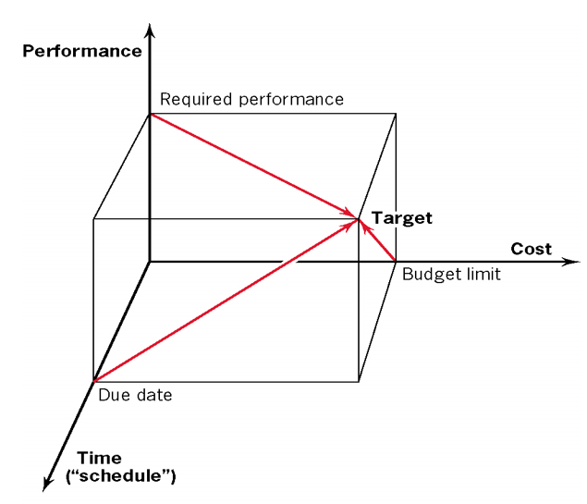

After considering the constraints the team leveraged the Project Priority Matrix to identify which of the three criteria should be constrained, enhanced or accepted. The project priority matrix may be found below.

***Figure 2****: Project Priority Matrix*

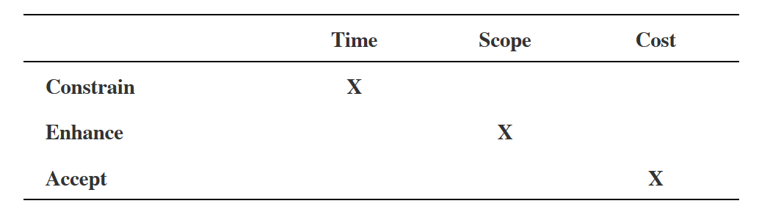

## Creating the Work Breakdown Structure

After the team decided on the project’s priorities and had developed the Project Scope Statement focus shifted to developing the work breakdown structure. This process assisted the team in subdividing the activities which required completion into smaller work elements. As part of the on-going Monitoring and Control stage the team reviewed each package and discussed how each contributed to the whole and the various interdependencies. Below is a listing of the activities which comprised the WBS.

***Figure 3****: Conveyor Belt WBS*

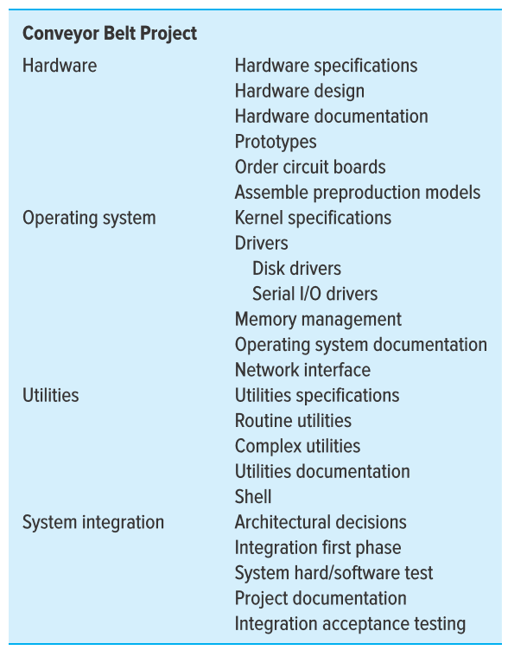

## Coding the WBS

With the activities subdivided the team utilized MS Project to assist in coding the WBS. Below is the final product which would assist the team as it moved into the Planning stage of the lifecycle.

***Figure 4****: WBS of Conveyor Belt Project in MS Project*

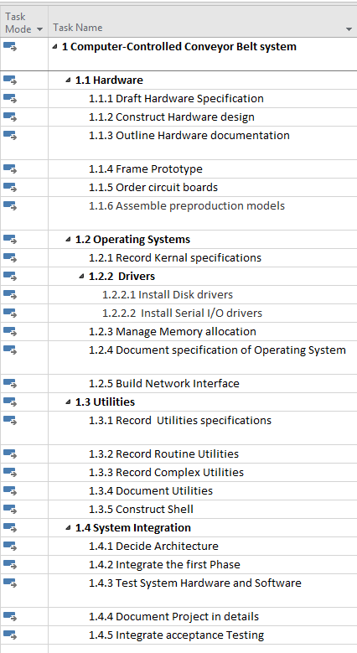

# Planning

After the specifications of the project were defined as well as the tasks identified and responsibilities established it was necessary to move into the planning stage of the project. In this important stage the team was tasked with baselining as it relates to cost and schedule and developing the components to address project risk(s). The artifacts which helped to address these requirements included leveraging the Gantt Scheduling Table and Chart, creating a Project Network Diagram and developing the Risk Assessment Form, Risk Response Matrix, Quarterly Cash Flow Table, Baseline Budget Report, Project Cost and Schedule Baselines.

In the initial assessment for the planning stage it was necessary to develop a schedule which would help define how long the project would take to complete. The team reviewed the tasks, determined the amount of slack and identified the critical path. When the critical path and amount of free slack days was established the team assessed the sensitivity of the network and determined it to be low. An outline of the critical path as it relates to activities may be found in the figure below.

***Figure 5****: Critical Path*



Please see Appendices A and B to view the schedule after the team identified the critical path.

After all of the activities were analyzed as they corresponded to the completion of the project, the team developed two milestones identifying important events which would mark “identifiable accomplishments towards the project’s completion”. The first addressed the hardware assembly of the system which was deemed important as the preproduction models would assist in providing an overview for how the final product would turn out (which would then help performance testing for any needed modifications). After some debate the team decided that the second milestone should focus on the completion of the activity: System Integration. As this activity involves testing and project documentation it was a candidate and fit the criteria for significance and relevance.

Towards the end of this phase the team reviewed the various advantages and disadvantages of analyzing/utilizing the Network Diagram versus the Gantt Chart in MS Project. The comparative analysis may be found in the table below.

***Table 1:*** *Advantages and Disadvantages to the Network Diagram and Gantt Chart*

|  |  |
| --- | --- |
| **Advantages** | |
| **Gantt Chart** | **Network Diagram** |
| Offers the ability to focus on tasks and time management | Allows persons to view a high-level plan to understand the project workflow |
| Provides more details on  project progress | Distances project complexity while offering a better representation of relationships among project activities |
| **Disadvantages** | |
| **Gantt Chart** | **Network Diagram** |
| Cannot be easily viewed on a single paper | Complex for large projects which can lead to misinterpretation |
| Does not function well when dealing with large projects | Time consuming |

After the initial outline for the schedule was developed the team focused on resource allocation or assigning personnel to various work packages. Soon it became apparent to the team that issues existed for several resources (Design, Development and Documentation) which was in part identified during the on-going Monitoring and Control stage. In an attempt to address this issue the team leveled both within and outside of slack, however, neither assisted. This left the group with two options. The number of resources would need to be increased or the duration of the project (schedule) would need to be increased. Please see Appendices C and Dfor screenshots of the Gantt chart with the schedule table after leveling within and outside of slack.

To address the issue identified the team decided to assign two additional development teams and an external development team to the project. After assigning the teams the project management team levelled within slack and the overallocation of resources was resolved. Please see **Appendix E** for a screenshot of the Gantt chart presenting the new schedule after the resources were added.

At this stage it was important to consider the various project risk(s) faced and determine means of mitigation and contingency plans where applicable. To do this the team developed a risk assessment form which highlighted various risks present to the project, their likelihood and impact, risk score and point in time for which they may be relevant. To assign a weighting for likelihood and impact the team used the following risk severity matrix.

***Figure 6****: Risk Severity Matrix*

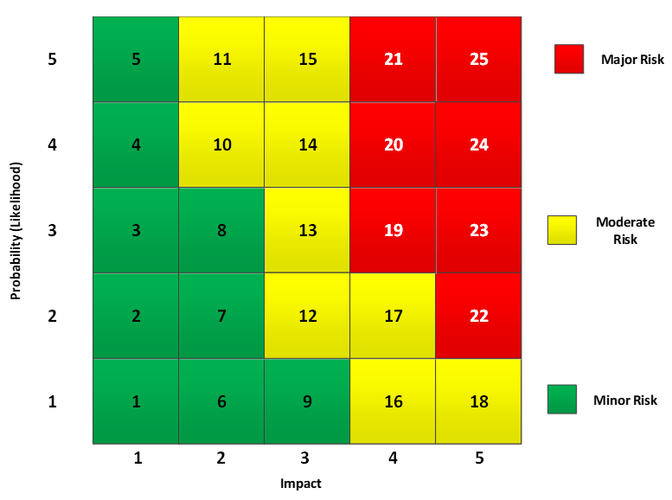

Below is the risk assessment form the team created to highlight the various project risks.

***Table 2****: Risk Assessment Form*

|  |  |  |  |  |
| --- | --- | --- | --- | --- |
| **Risk Event** | **Likelihood** | **Impact** | **Risk Score** | **When** |
| Network Failure | 2 | 2 | 7 | Operating System Construction |
| Failure of Disk Driver after Installation | 2 | 2 | 7 | Operating System Construction |
| Hardware Malfunctioning | 3 | 2 | 8 | Hardware |
| Testing of Software and Hardware | 1 | 1 | 1 | System Integration |
| Shell components do not meet quality control guidelines | 1 | 2 | 6 | Utilities Construction |

After the risk events were identified along with their corresponding risk scores the team developed a Risk Response Matrix in order to highlight the appropriate response given the presence of the risk, what the contingency plans were, the trigger which would signify that the risk had occurred, and the responsible party for addressing the risk. All of these components functioned hand in hand with the Monitoring and Controlling stage as oversight for each of the activities and the due diligence to plan for the project risk(s) are necessary components of each stage. Below is the Risk Response Matrix as it correlates to the risks ascribed in the Risk Assessment Form.

***Table 3****: Risk Response Matrix*

|  |  |  |  |  |
| --- | --- | --- | --- | --- |
| **Risk Event** | **Response** | **Contingency Plan** | **Trigger** | **Who Is Responsible** |
| Network Failure | Mitigate: Select specific network and monitor it | Additional staff allocation plan in event of issues | Alerts in the system | Development Team |
| Failure of Disk Driver after Installation | Mitigate: Re-install it | Order replacement drivers | System Alert | Development Team |
| Hardware Malfunctioning | Mitigate: Select better vendor | Order replacement | Hardware malfunction | Design Team |
| Testing of Software and Hardware | Mitigate: Backup source | Contractors on standby for support where needed | System alert | Development Team |
| Shell components do not meet quality control guidelines | Mitigate: Incorporate QC checks into process | Order replacement components | Call from construction staff | Development Team |

In assessing the risks and assigning their risk scores the team next determined the potential for impact and magnitude if the events were to occur. Along with assessing the probability the team identified the amount required to have on hand within the budget reserve. This information along with the work package where the event would take place may be found in the table below.

***Table 4****: Contingency Reserve*

|  |  |  |  |  |
| --- | --- | --- | --- | --- |
| **Risk** | **Work Package(s)** | **Probability** | **Cost Impact** | **Budget Reserve** |
| Network Failure | 1.2.5 | 20% | $45,000 | $9,000.00 |
| Failure of Disk Driver after Installation | 1.2.2.1 | 30% | $30,000 | $9,000.00 |
| Hardware Malfunctioning | 1.1.4 | 35% | $30,000 | $10,500.00 |
| Testing of Software and Hardware | 1.4.3 | 9% | $5,000 | $450.00 |
| Shell components do not meet quality control guidelines | 1.3.5 | 10% | $25,000 | $2,500.00 |
| **Total Budget Reserve** | | | | **$28,950.00** |
| **Total Management Reserve: Three Times the Budget Reserve** | | | | **$86,850.00** |

After the team performed the necessary due diligence to assess, identify and prepare for risk events the focus shifted to baselining project cost and the schedule.

Reviewing the quarterly cash flow report assisted in identifying trends where applicable. As may be seen in Appendix F, the cost distribution is fairly consistent over the lifespan of the project. The cash flow increase during the second quarter of the first year is one of the only noticeable discrepancies in the distribution. Also, it is important to note the cumulative cost of the first three quarters is more than half of the project. Reviewing the breakdowns as it related to cost assisted the team in understanding where expenses were to occur based on the allocation of resources and schedule.

Finally, leveraging the cost table which may be found in Appendix G, the team was able to submit the Cost Baseline for approval by senior management.

Overall, the Planning stage was significant in preparing the team for the Execution stage. In planning as it relates to scheduling and cost along with identifying, assessing and preparing for project risk(s) were crucial and allowed the team to have a more holistic idea as to how the project would hopefully unfold. The hours and resources invested into each of these components and artifacts have assisted greatly and as the project nears completion the team is prepared for any unforeseen events if they should arise.

# Executing

Executing as part of the project lifecycle focuses on the majority of the project work that is completed and the project team’s analysis of the control elements consisting of time, cost and specification to ensure requirements are met. The Execution stage functioned alongside the Monitoring and Control stage as the project team discovered potential management issues and developed Keys to Success to ensure timely and efficient project completion. The team also reviewed status reports over the lifespan of the project and used them to inform senior management where applicable.

Below is a listing of management issues the team found during the Execution stage:

1. As per the status report, the project is delayed by 19 days, however, the project must be completed in 530 days. Since the project is time-constrained, additional resources must be added in order to complete the project on time.
2. Management must accept that since the project has been delayed, the project might go over budget (as adding new resources will likely increase expenses). The project team will need approval for costs associated with training, overtime and overhead.
3. There could be a possible conflict between different projects for which the resources are utilized, since there is addition of more resources at later stage.
4. Overtime could be an issue which could negatively impact the employees working on the project. There could be lack of work life balance.
5. In order to bring the project back on time, existing resources will need to work overtime, or an external team will need to be hired.

Considerations for the Project Manager as it relates to potential issues are as follows:

1. The project manager should be aware of the existing issues and the hurdles that are in the path towards project completion.
2. The project manager should pay attention to details and make sure that all activities are getting completed on time without any significant delay.
3. There should be a proper communication channel between team members and the project manager to keep the expectation(s) clear.
4. The project manager should act as a bridge between higher management and the team members to keep the project flowing smoothly.

Along with the issues and considerations highlighted above, the team developed the below Keys to Success to assist in alleviating the issues and ensure the project is aligned for successful, on time completion.

1. To assist with motivation and foster strong employee relationship, a team building event has been scheduled outside of working hours
2. A new Rewards and Recommendations program has been instituted that the project team will leverage to recognize employees who have gone above and beyond in their line of duties. The program offers employees gifts based on performance and work output.
3. The team should quickly get accustomed to the organizational culture and should work together to achieve project’s goal.
4. The project should have a proper risk management system in place.

A necessary and vital component of the Executing stage is analyzing status reports to drive decision making where applicable and use them in informing senior management of progress. Below are the Earned Value Summaries for each quarter during the lifespan of the project along with forecasts to assist with decision making.

## Quarter 1:

**Earned Value Summary:**

|  |  |  |  |  |  |
| --- | --- | --- | --- | --- | --- |
| **PV** | **EV** | **AC** | **SV in days** | **CV** | **BAC** |
| **$137,120.00** | **$155,980.83** | **$151,680.00** | **3** | **$ 4,300.83** | **$1080,150.00** |
| **ETCf** | **EACf** | **VACf** | **CPI** | **PCIB** | **MRI** |
| **$898,687.21** | **$1,050,367.21** | **$29,782.79** | **1.03** | **1.9461** | **0.049** |

Summary:

The estimate time to complete the project is 526 days, which infers that the project is on schedule. The performance indices indicate that the project is under budget by $4300 and is ahead of schedule by 3 days. The CPI of 1.03 indicates that the project is more cost efficient in terms of work accomplished to date.

Forecasting: TCPI is 1 which indicates that the ability to complete the project within the given budget.

To view the Gantt Tracking table for this quarter please see Appendix H.

## Quarter 2:

**Earned Value Summary:**

|  |  |  |  |  |  |
| --- | --- | --- | --- | --- | --- |
| **PV** | **EV** | **AC** | **SV in days** | **CV** | **BAC** |
| **$445,520** | **$454,431.37** | **$470,720.00** | **6** | **($ 16,288.63)** | **$1080,150.00** |
| **ETCf** | **EACf** | **VACf** | **CPI** | **PCIB** | **MRI** |
| **$648,146.89** | **$1,118,866.89** | **($38,716.89)** | **0.97** | **0.42** | **(0.19)** |

Summary:

The problem of cost variance arises from Q2 onwards. It has cost variance of ($16,288.63), which depicts it running overbudget and ahead of schedule by 6 days. Also, CPI has reduced from 1.03 to 0.97 which implies that in quarter 2 project has lost 3% worth of work for every dollar spent

Forecasting: The forecast budget at completion is $ 1080,150 and project in quarter 2 is over budget by $38,716.89. TCPI of 1.03 indicates a need for increased performance for the remaining work of the project to stay within budget.

To view the Gantt Tracking table for this quarter please see Appendix I.

## Quarter 3:

**Earned Value Summary:**

|  |  |  |  |  |  |
| --- | --- | --- | --- | --- | --- |
| **PV** | **EV** | **AC** | **SV in days** | **CV** | **BAC** |
| **$598,320.00** | **$608,400.00** | **$627,760.00** | **9** | **($ 19,360.00)** | **$1080,150.00** |
| **ETCf** | **EACf** | **VACf** | **CPI** | **PCIB** | **MRI** |
| **$486,761.64** | **$1,114,521.64** | **($34,376.64)** | **0.97** | **0.97** | **(0.22)** |

Summary

In third quarter, the cost variance has reached to ($19,360.00) and is ahead of schedule by 9 days. CPI has remained the same that is 0.97 indicating that project is over budget.

Forecasting: Project in quarter 3 is over budget by $ 34,376.64. TCPI of the project in quarter 3 is 1.04 indicating a need of better performance for the remaining part of project to stay within budget and schedule.

To view the Gantt Tracking table for this quarter please see Appendix J.

## Quarter 4:

**Earned Value Summary:**

|  |  |  |  |  |  |
| --- | --- | --- | --- | --- | --- |
| **PV** | **EV** | **AC** | **SV in days** | **CV** | **BAC** |
| **$683,440** | **$688,384.92** | **$717,840** | **-19** | **($29,445.08)** | **$1,080,150** |
| **ETCf** | **EACf** | **VACf** | **CPI** | **PCIB** | **MRI** |
| **$408,528.19** | **$1,126,368.19** | **($46,218.19)** | **0.96** | **0.637** | **-0.34** |

Summary: The project is 19 days behind schedule and has cost variance of ($29445.08).

Forecasting: The project is over budget by and is 19 days behind schedule. TCPI is 1.08 which infers a need for increased performance for the remaining work of the project to remain within budget

To view the Gantt Tracking table and the Earned Value Report for this quarter please see Appendices K and L.

# Closing

At this stage the team is not ready to close out the project. There is an issue with finishing on time and it is necessary to review the methods by which the project can get back on schedule. Below is a list of options by which the team reviewed to address the issue.

* Adding additional resources to work packages
* Institute overtime for salaried employees – assigned to work packages
* Using external resources

In reviewing the options listed above the team identified the activity Serial i/o as a good candidate for adjustment to assist in bringing the project back on schedule. Adding overtime to this activity (240 hours) brought the schedule back to 529 days with an additional cost of $8,400, reducing the EAC from 1,129,116.33 to 1,123,694.00. The team decided it could find a more viable solution and added an external resource to the activity. In doing so the cost increased $25,400 and the schedule dropped to a completion time of 495.5 days. The team believed at this point a more optimal solution existed which would save the company more money.

In reviewing internal resources, a developer was found idle at this point in the project. Reallocating the resource to the Serial i/o activity reduced the schedule to 495.5 days, there were no additional costs and the EAC reduced from 1,129,116.33 to 1,113,561.13. The team decided this was the most optimal solution for which to bring to senior management’s attention.

Looking into the future the team will need to address the following components in order to successfully close out the project.

1. Obtaining delivery acceptance from the customer

2. Shut down the resources involved in the project and release them to new uses/projects, etc.

3. Evaluate the project manager and team members (including conducting performance evaluations and

delivering input to functional managers where applicable) then reassign the team members

4. Close all accounts and pay all of the bills

5. Deliver the project to the customer

6. Create the final report which will include lessons learned

# References

The Managerial Process, 7th Ed., Larson and Gray, McGraw-Hill-Irwin, ISBN-13: 9781259924477 ISBN-10: 1259924475.

Pxhere.com. (2018). Available at: https://pxhere.com/en/photo/1070638 [Accessed 9 Dec. 2018].

Appendix a – SCHEDULE TABLE

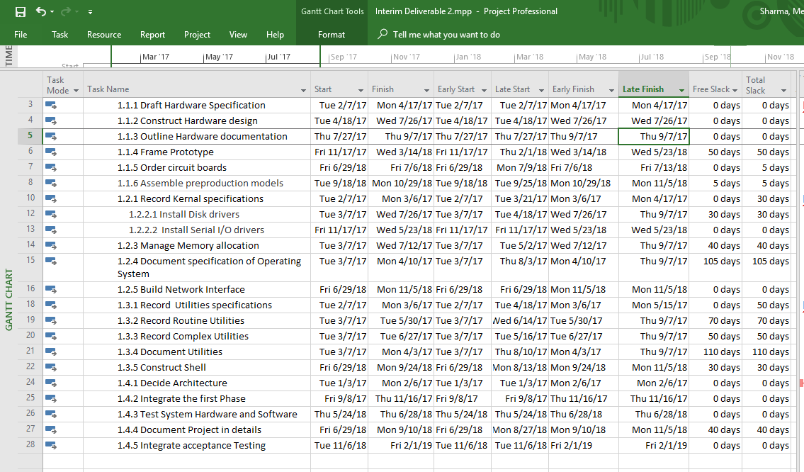

Appendix B – GANTT CHART

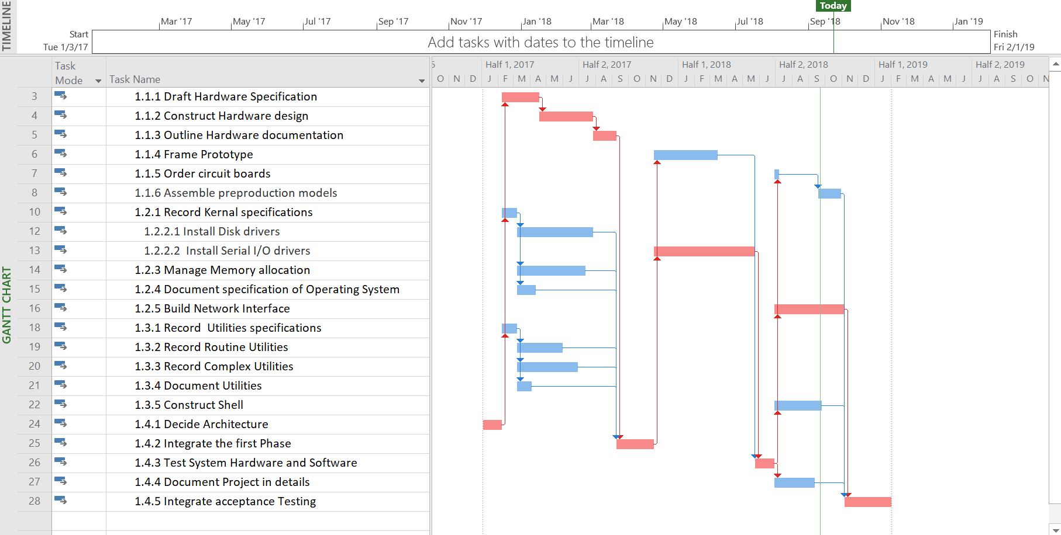

Appendix c – gantt chart with SCHEDULE TABLE Leveling within slack

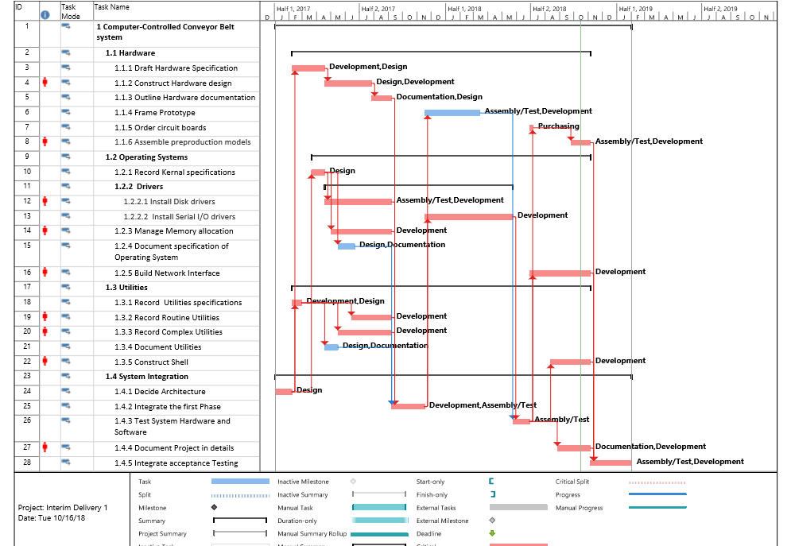

Appendix d – gantt chart with SCHEDULE TABLE leveling outside of slack

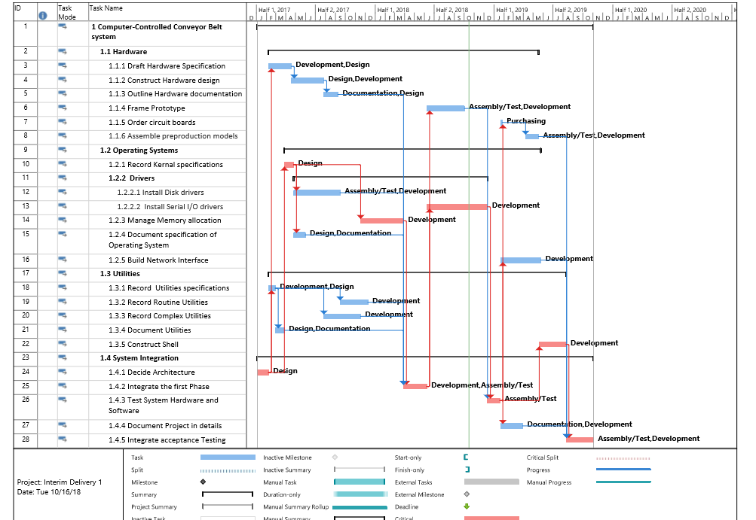

Appendix E: Gantt chart witH Schedule Table Presenting the new schedule

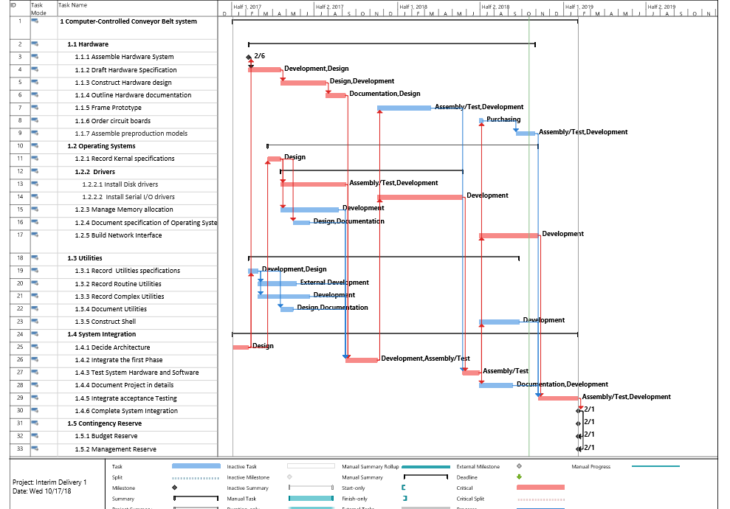

Appendix F: Quarterly cash flow

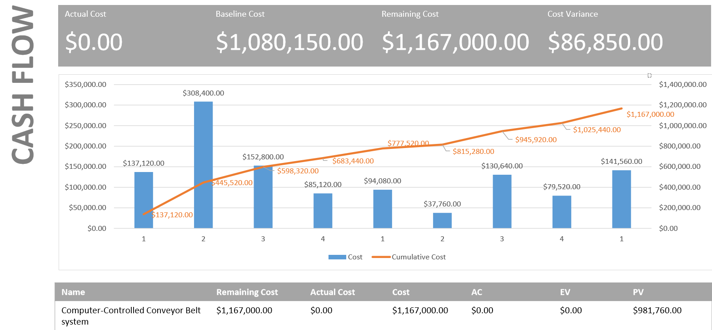

APPENDIX G: cost table

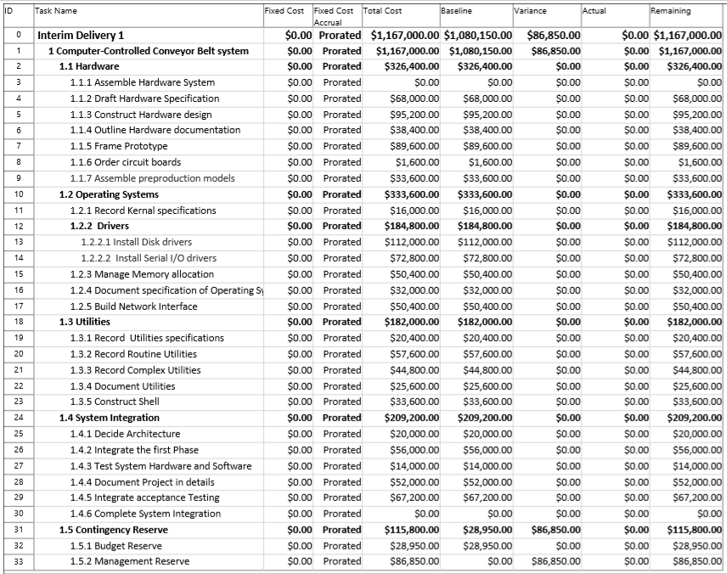

Appendix H: Gantt tracking table for quarter 1

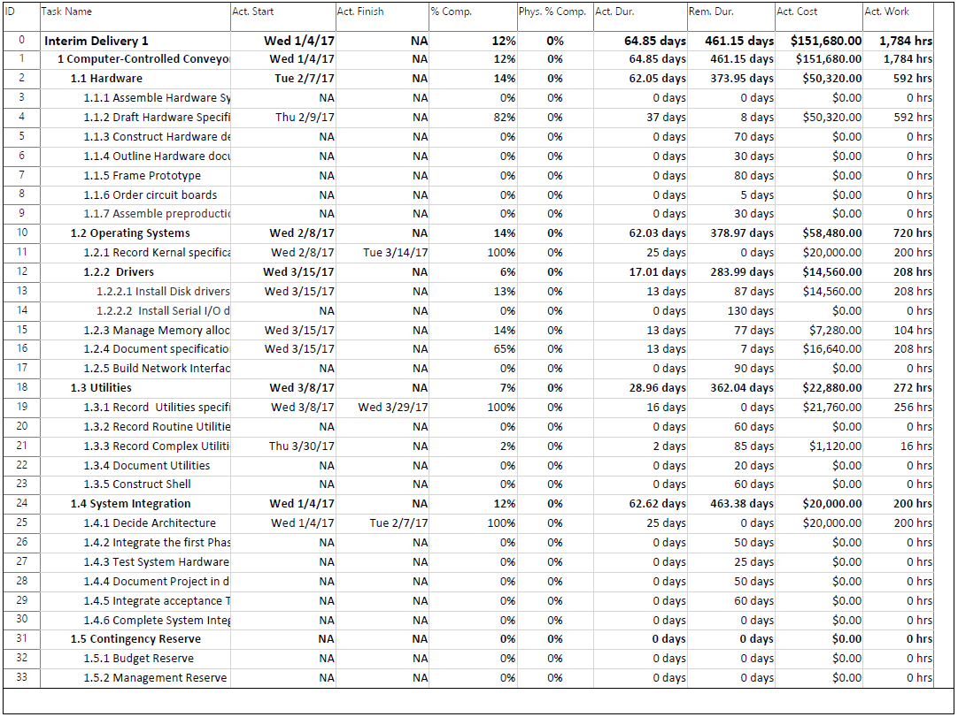

Appendix I: gantt tracking table for quarter 2

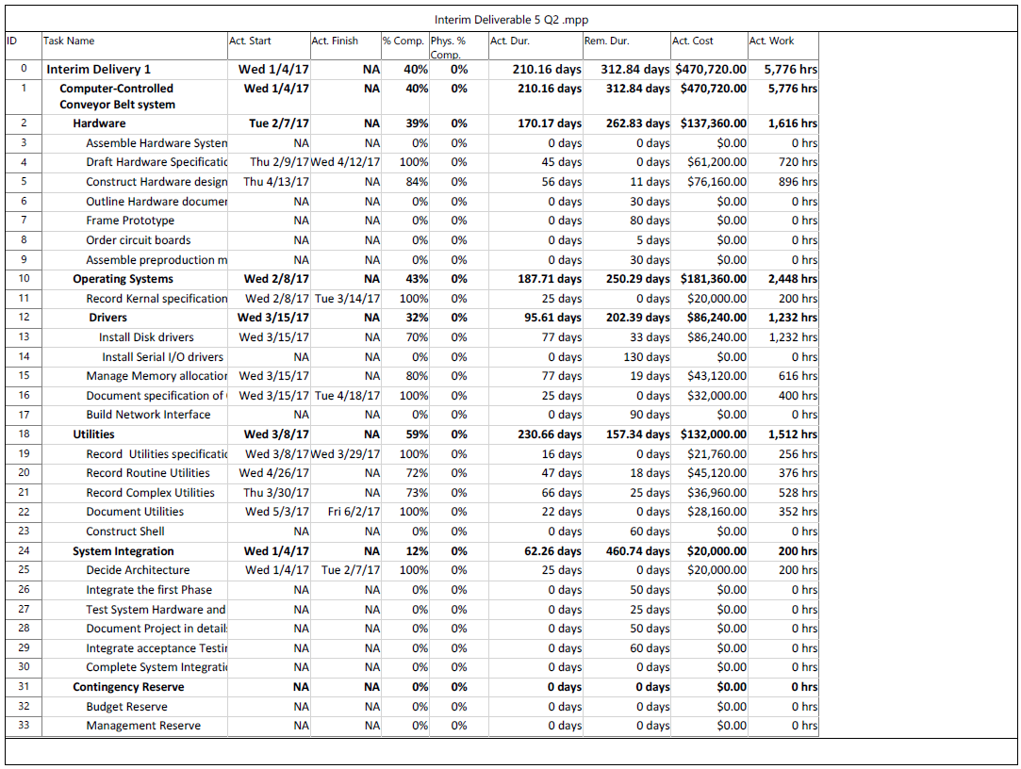

Appendix J: gantt tracking Table for quarter 3

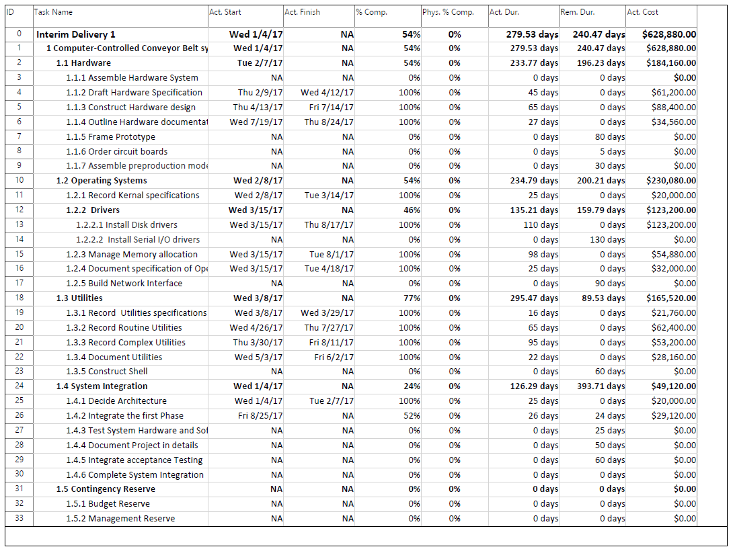

Appendix K: gantt tracking table for quarter 4

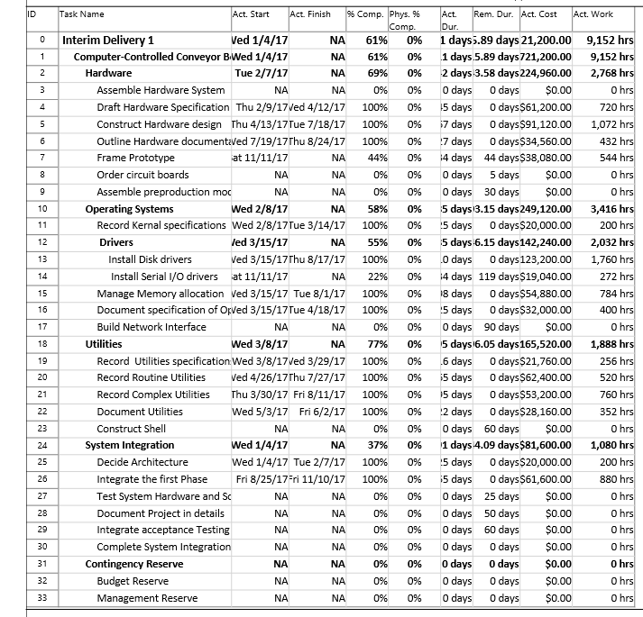

APPENDIX L: EARNED VALUE REPORT for quarter 4

